CTI Clonmel

Raheen College

Gaelcholáiste Chéitinn

Mobile Phone Policy

May 2023

|  |  |
| --- | --- |
| Policy Area | Schools |
| Document Reference Number | CTI/PHONE/011/0 |
| Version No. | 2 |
| Document Drafted by | Central Technical Institute |
| Date previous version:  adopted by TETB | 12th June 2018 |
| Reviewed / Amended by School | May 2023 |
| Reviewed and Ratified by Senior Management Team – CE and Directors | 22nd May 2023 |
| Date Noted / to be Noted by TETB | 5th September 2023 |
| Policy Review Date | Every two years |
| Date of Withdrawal of Obsolete Document | 22nd May 2023  Document Ref. No. CTI/PHONE/011/0  Version No. 1 |

**Central Technical Institute Clonmel**

Raheen College & Gaelcholáiste Chéitinn

**Mobile Phone Policy**

Our Mobile Phone Policy and all school policies are under pinned by the five Core Values of the Tipperary ETB Ethos Framework.

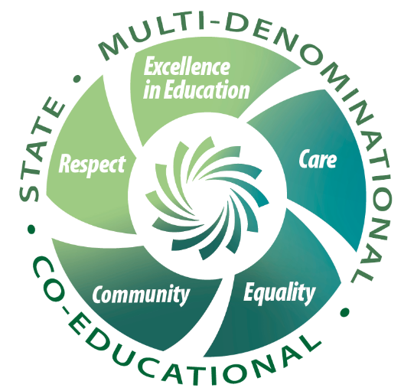

These values sum up the essence of our Mobile Phone Policy.

# 1.0 Mobile Phones in our School

**1.1 Legislative Context**

The Mobile Phone Policy is developed in line with legislative requirements –

* Data Protection Act 2018 - this act gives effect to the General Data Protection Regulation (GDPR) May 2018 in the Irish context.
* Data Protection Act 1998 - this act was passed to deal with privacy issues arising from the increasing amount of information kept on a computer about individuals.
* Data Protection (Amendment) Act 2003 - this amendment extends the data protection rules to manually held records and makes improvements to the public’s right to access data.
* General Data Protection Regulation (GDPR) (EU) 2016/679.
* Child Trafficking and Pornography Act 1998 - this act legislates against anyone who knowingly produces, prints, publishes, distributes, exports, imports, shows, possesses, or sells child pornography.
* Interception Act 1993 – this act stipulates that telecommunication messages can be intercepted for the purpose of an investigation of a serious offence. Authorisations are subject to certain conditions.
* Video Recordings Act 1989 - this act prohibits the distribution of videos which contain obscene or indecent material which may lead to the depravation or corruption of the viewer.
* Copyright and Related Rights Act 2000 – this act governs copyright in Ireland.
* Harassment, Harmful Communications and Related Offences Act, 2020.

**Other relevant legislation may include**:

* The Education Act (1998)
* The Equal Status Act (2000)
* Dignity at Work Charter (2007)
* Children First Act (2015)

**Links with other policies**

This policy should be read in conjunction with all other school policies, and in particular with:

* Code of Behaviour
* Acceptable Usage Policy
* Anti-bullying Policy
* DEIS Plan
* Child Protection Policy
* Whole School Guidance Policy
* School Trips Policy

**1.2 Definition**

For the purposes of this policy “mobile phones” is the generic term CTI Clonmel applies to mobile phones, smart phones, personal musical devices, or any other personal electronic/digital device which can be used to do some or all the following:

* record audio and/or video.
* take photographs/images.
* transmit/receive images or recordings or other media.
* transmit/receive phone calls, text messages.
* upload/download to or from the internet.

**1.3 Rationale**

CTI Clonmel has developed this mobile policy in line with our Core Values of Excellence in Education, Respect, and Community in particular. The aim of the policy is to ensure appropriate access to beneficial technology, and to balance this against the rights of students and staff to privacy, respect, communications, and safety. Mobile phone usage within the classroom environment has been seen to have a negative impact in the classroom, in terms of distractions and disruptions to the teaching and learning environment. This policy is to be implemented in conjunction with the AUP.

**2.0 Terms of Mobile Phone Usage:**

Having consulted with parents, staff, students and the BOM the following were agreed as acceptable terms of use for mobile phones:

1. Students are permitted to have their mobile phone in school and are the responsibility of the student throughout the day. (While CTI Clonmel is permitting students to bring mobile phones to school, it should be noted that CTI Clonmel accepts absolutely NO RESPONSIBILTY for loss or damage to phones. Students are responsible for minding their own property.)
2. Phones **must** be turned off and kept out of sight during the school day. This applies before school starts, during lessons, between lessons, at breaks and while leaving the school premises. Phones may not be switched on between classes.
3. The charging of mobile phones on the school premises is forbidden.
4. In line with the State Examinations Commission policy, all mobile phones must be surrendered to the exam superintendent for the duration of each JC, LC and LCA examination.

**2.1 In order to assist our school in implementing this**:

1. Parents must **not** contact their child by mobile phone during the school day under any circumstances.
2. Similarly, students must not contact (ring or text) their parents by mobile phone during the school day.
3. All contact and communication must be via the school office at (052) 6121450 (Raheen) / (052) 6126269 (Gaelcholáiste) or [info@cti-clonmel.ie](mailto:info@cti-clonmel.ie), and students are directed to use the office telephone if needed: this is especially important where emergencies arise as it allows the school to provide appropriate support for a student who may become distressed or upset.
4. Any messages for a child or parent will be relayed by the office. (During the consultation phase, a substantial majority of parents indicated that communication should take place via the office.)
5. It is the responsibility of students and parents/guardians to ensure the safety and security of mobile devices. It is advisable that phones and any other personal digital devices are kept in the student’s bag for safety.
6. We remind parents that the loss/damage of devices brought to school is not the responsibility of the school.
7. It is strongly advised that students mark their mobile phones with their names and use passwords to ensure unauthorised use cannot be made of their devices. Students should never share their passwords with anyone else.
8. The Department of Education does not recognize mobile phones as appropriate for use as calculators or clocks. The school embraces the Department policy and therefore, students using this as a pretext, should not produce mobile phones in class to carry out tasks requiring a calculator or to check the time.

**2.2 Sanctions**

In the event of students having their phones on or in use during the school day, the following sanctions will apply:

1. The phone will be confiscated by the class teacher. This will result in the phone being held in the school Front Office and will only be returned to the student at the end of the school day.
2. Failure on behalf of the student to surrender their phone, when requested to do so, will result in the student being removed from class and their parents will be requested, by the Principal /Deputy Principal, to come to the school to assist in the removal of the phone from the student’s possession. If the student continues to refuse to hand over the phone their parents will be requested to take them home until a resolution can be reached.
3. If a student’s phone is confiscated on three occasions throughout the academic year, this will result in the phone being held in the school Front Office until it can be collected by a parent/guardian at the end of the school day.
4. Repeated breaches of this rule means that the parent/guardian will be told that the student must leave their phone at home. This means that the student will not be allowed bring the mobile phone to school for the remainder of the term or school year, at the discretion of the school and management.

Any staff member/teacher has the right to confiscate a personal electronic device if a student is observed by the teacher/staff member using it without permission on school premises or if a student is using it in situations which are in clear breach of our AUP and Code of Behaviour Policy.

A continued breach of these sanctions will result in the implementation of our Code of Behaviour. A copy of our Code of Behaviour Policy can be received from our school office or can be found on our website.

**Note:**

It should be noted that it is a criminal offence to use a device or mobile phone to menace, harass or offend another person. As such, the school may consider it appropriate to report such incidents to the Gardaí and Tusla.

**Student and Parent/Guardian Cooperation:**

The school authorities request the total cooperation of Parents/Guardians in this matter as the policy is in place to ensure the health and safety of all the school community and to provide the best possible environment in which teaching and learning can take place. There will be ongoing communication between the school, students, and parents/guardians regarding the usage of phones and the Mobile Phone Policy to address any concerns or issues.

To this end, students and their Parents/Guardians are expected to sign their agreement to abide by the terms of CTI Clonmel’s Mobile Phone Policy.

**Central Technical Institute reserves the right to modify, add to or alter details of this Mobile Phone Policy at short notice.**

Ratified by the BOM on

Chairperson

Secretary