**CTI Clonmel**

Raheen College &

Gaelcholáiste Chéitinn

May 2024

**Classroom Based Assessment Policy**

 

|  |  |
| --- | --- |
| Policy Area | Schools |
| Document Reference number | CTI/JC.CBA/080/0 |
| Version | 1 |
| Document Drafted by | Central Technical Institute Clonmel |
| Date previous version:  adopted by SLT  noted by TETB | 14th June 2022  6th September 2022 |
| Date Reviewed / Amended by School | May 2024 |
| Date Reviewed / Ratified by Senior Management Team – CE and Directors |  |
| Date noted / to be noted by TETB |  |
| Policy Review Date | Bi-Annually |
| Date of Withdrawal of Obsolete Document |  |

**Policy on Junior Cycle Classroom Based Assessment (CBA) procedures in CTI Clonmel.**

The Junior Cycle spreads assessments throughout the three years of Junior Cycle giving students the opportunity to demonstrate their learning away from an examinations setting. All Junior Cycle courses incorporate two new elements to the assessment of students:

• Classroom Based Assessments

• Assessment Tasks

The focus of this policy is on Classroom Based Assessments

**Classroom Based Assessments (CBAs)**

**What are CBAs?**

* Classroom-Based Assessments (CBAs) provide students with opportunities to demonstrate their learning and skills in ways not possible in traditional terminal examinations
* An aim of completing CBAs is to allow students develop the key skills of Junior Cycle (Appendix 1)
* The assessments associated with CBAs will cover a broad range of activities including oral tasks, written work of different types, scientific experiments, practical or designing and making tasks, artistic performances, projects, creating an artifact or other suitable tasks depending on the subject in question.
* CBAs will be undertaken in all subjects and short courses in the new Junior Cycle and will be facilitated by the subject departments within CTI Clonmel.
* Students complete all assignments under the guidance of their subject teacher within a specified timeframe.

**When will the CBAs be held?**

* Students will complete one CBA in Second Year and usually one in Third Year in each Junior Cycle subject. The exception is Gaeilge, where both CBAs are completed in 3rd year.
* CBAs will be undertaken during a defined timeframe within school contact time. A CBA timetable will be available for both 2nd and 3rd year students at the beginning of each school year.

**Communication with Parents**

* Parents of Junior Cycle students will be notified of the CBA calendar at the start of each academic year.
* The CBA calendar will be given to all 2nd and 3rd year students at the beginning of each academic year.
* The CBA calendar will also be available on the school website.

**Audio Visual Recordings**

* In CBAs, where audio-visual / audio recording is required, it is school policy that all students are recorded. These audio-visual recordings are saved securely until after all descriptors have been finalised.
* These recordings are to be made on school devices only.
* If a teacher wishes to use a student’s CBA audio-visual / audio recording as an exemplar for other students, then written permission must be sought from the parent and the student in question. This permission letter should then be put in the student file. After this, all other audio-visual recordings relating to CBAs should be deleted. This written permission is available as Appendix 2.
* Please note that while you may have consent from a student to use their assessment and their personal data, this consent does not extend to any personal data/identifying information of any other individual(s) that may be contained within the same assessment.

**How are CBAs assessed?**

* The students’ CBAs are assessed by their teachers using nationally agreed features of quality designed by the National Council for Curriculum and Assessment (NCCA).
* Once the CBAs have been corrected by the class teacher, all Junior Cycle teachers in the subject department will meet in a process called a SLAR (Subject Learning and Assessment Review) meeting.
* The CBA results will be reported in the Junior Cycle Profile of Achievement (JCPA) using the following descriptors:
  + Exceptional
  + Above Expectations
  + In Line with Expectations
  + Yet to Meet Expectations
  + Not Reported
* Any written material completed by students as part of their CBA work, may be used as exemplars of good practice for other students. In this case, written permission must be sought from the parent and the student in question.

**Students with SEN**

In line with department recommendations all SEN students will have access to any resources/support they would have access to in their regular day to day school experience. This may include the use of a laptop, resource support, access to an SNA etc.

**Absentee Students**

All CBAs are compulsory. A serious medical condition certified by a doctor is the only valid reason for not completing a CBA.

Absentee students may be accommodated in each subject department up to and including the school day prior to the SLAR meeting **where possible**.

CBAs generally span 3 / 4 weeks. Therefore, all students should have adequate time to complete and report on their CBA.

Any student who does not complete a CBA will have the comment ‘Not Reported’ recorded on their Junior Cycle Profile of Achievement.

**SLAR (Subject Learning and Assessment Review)**

The purpose of the SLAR is to establish that standards across the department are in line with national guidelines ensuring the fairness and integrity of the CBA.

* Each department will nominate a SLAR coordinator
* The SLAR facilitator is entitled to 2 hours planning time for each SLAR meeting (One meeting for each CBA), which is held within 7 days after the completion of the CBA
* The SLAR coordinator will then submit a record of the SLAR to the Principal.

**Reporting on CBAs**

* After each CBA and the relevant SLAR has been completed, subject teachers should provide each student with the descriptor they have been awarded and feedback on their CBA.
* CBAs may be included as an element of Christmas/Summer exams.
* CBA results are recorded on VS Ware and parents will have access to those results.
* The results of all completed CBAs will be reported on in the Junior Cycle Profile of Achievement (JCPA), which is issued from the school to each student at the start of the year following completion of the Junior Cycle Programme.

**Appeals**

* There is no facility for processing appeals.

**Record Keeping**

* Each subject teacher will maintain a record of descriptors awarded until after the JCPA (Junior Cert Profile of Achievement) has been awarded.
* An electronic version of these results should be forwarded to the Junior Cycle coordinator using Microsoft Teams.
* A results sheet is generated for each student by the Junior Cycle Coordinator. Subject teachers are responsible for the entry of the descriptor award for their students.
* The results are stored in a JC folder which is accessible by the JC Coordinator(s) and Management.
* It is the policy of CTI, that CBA material from both 2nd and 3rd year, should be stored until after results and appeals of all Junior Cycle examinations are concluded.
* All CBA material can then be returned to students.

Please do not hesitate to contact the school if you require further information or clarification on this policy.

**Addendum to policy;**

The Junior Cycle assessment adjustments in place since 2022 in relation to Classroom Based Assessment will remain for students sitting Junior Cycle in 2025 and 2026 (gov.ie - 17/04/24). This means that each student cohort will be required to complete a minimum of one Classroom-Based Assessment rather than the usual two.

Either CBA can be completed in a subject but with the following exceptions;

* + CBA 1 must be completed in MFL
  + CBA 2 must be completed in Gaeilge, Visual Art, Home Economics, Music, Applied Technology, Engineering, Graphics & Wood Technology

This policy was adopted by the Board of Management on _________________________ [date]

Signed: ______________________________________

*Chairperson of the Board of Management*

Signed: ______________________________________

*Principal*

Date: ________________________________________

Date of next review: ____________________________

**Appendix 1 – Key skills of Junior Cycle**

**(Framework for Junior Cycle, 2015)**

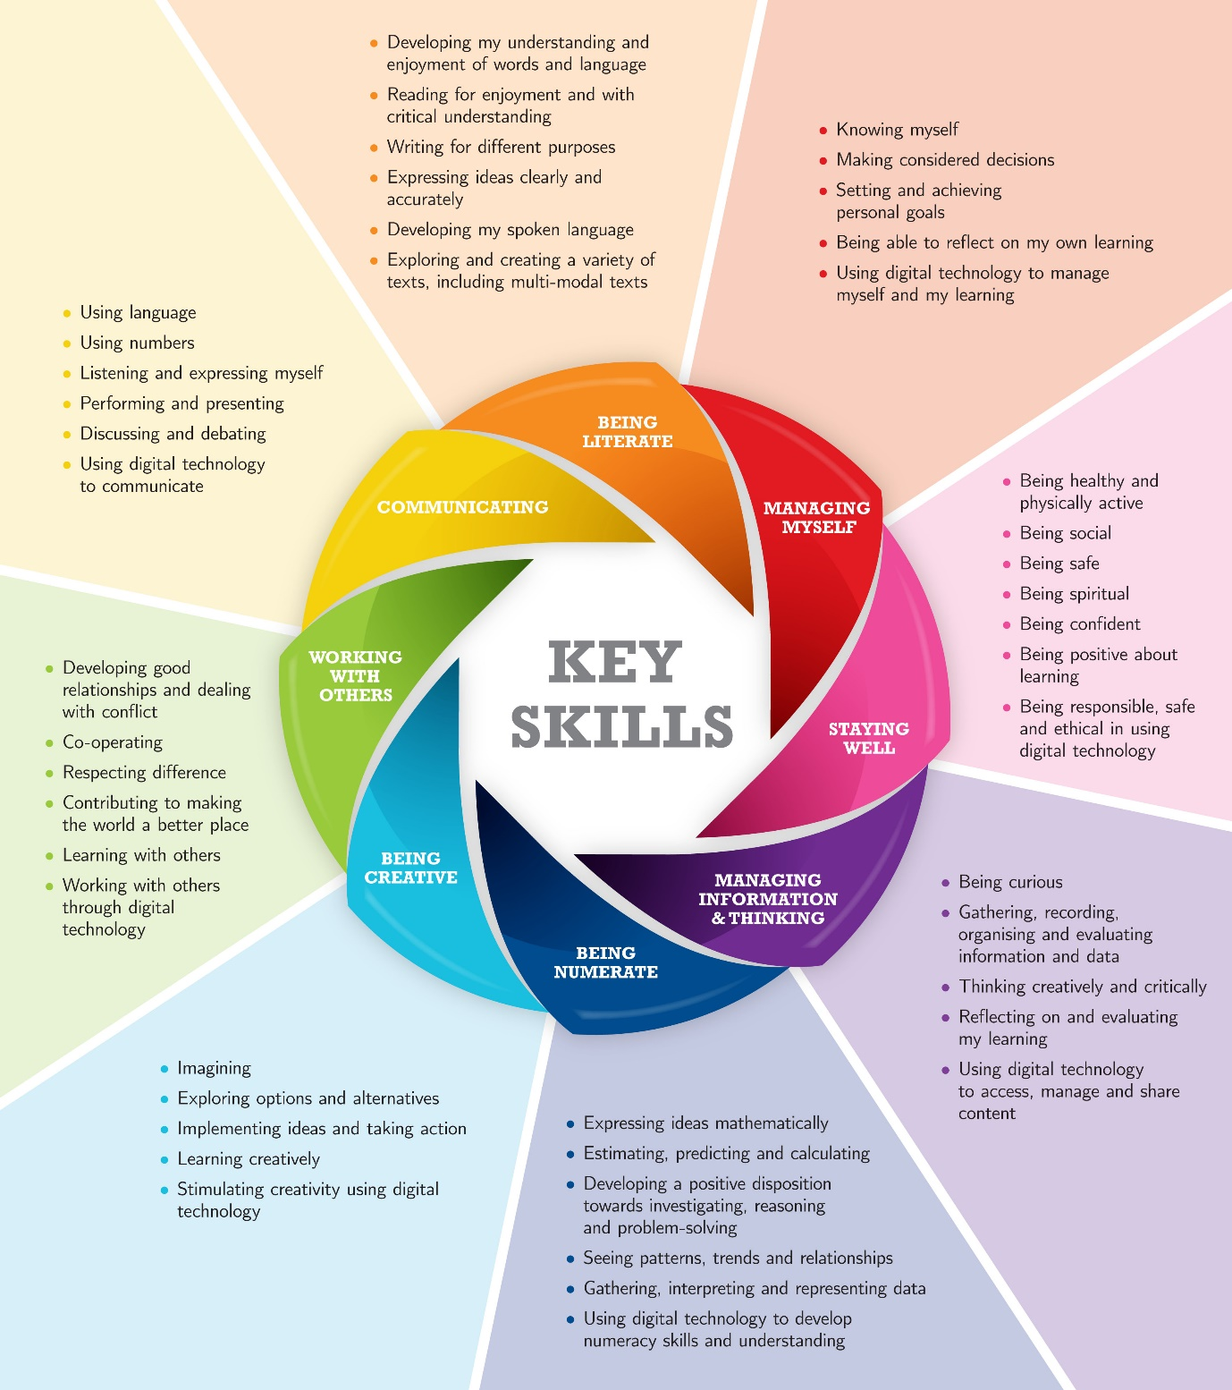

**Appendix 2 – Parental permission to use audio-visual / audio recording as an exemplar**

Dear Parent / Guardian,

On occasion, our students hand up work as part of their Classroom Based Assessments that is of an extremely high standard. In this case, class teachers may wish to use this work as an example of good practice to future classes, during the CBA process.

CBAs can be handed up by the student in the following formats;

* Written form
* Audio recording
* Audio visual presentation.

If you agree to allow your son/daughters Classroom Based Assessment work to be used as an exemplar of good practice in the school with all future classes, please complete the following permission form. This means that your son/daughters name or image may be available to these students.

Please note, you can withdraw this consent at any time by contacting the Junior Cycle coordinator in the school and the assessment(s) will not be used from this date forward.

I, _________________________________________________________ parent / guardian of ____________________________________________ agree to allow his/her work be shown as an exemplar of good work to other students.

Signed; _____________________________________________________ (Parent / Guardian)

Date; ______________________________

Signed; _____________________________________________________ (Student)

Date; ______________________________

Signed; _____________________________________________________ (JC Coordinator)

Date; ______________________________